**CMSC203 Assignment 2 Implementation (Documentation)**

Class: CMSC203 CRN 33099

 Program: Assignment #2

Instructor: Prof. Eivazi

 Summary of Description: (Give a brief description for each Program)

 Due Date: 02/23/2024

 Integrity Pledge: I pledge that I have completed the programming assignment independently.

 I have not copied the code from a student or any source.

Alvin Persaud

**Part1: UML Diagram**

|  |
| --- |
| Patient |
| * firstName : String * middleName : String * lastName : String * streetAddress : String * City : String * State : String * zipCode : int * phoneNumber : String * emergencyName : String * emergencyNumber : String |
| * Patient() * Patient(firstName : String, middleName : String, lastName : String) * Patient(firstName : String, middleName : String, lastName : String, streetAddress : String, city : String, state : String, zipCode : int, phoneNumber : String, emergencyName : String, emergencyNumber : String) * getFirstName() : String * setFirstName(firstName : String) * getMiddleName() : String * setMiddleName(middleName : String) * getLastName() : String * setLastName(firstLast: String) * getStreetAddress() : String * setStreetAddress(streetAddress : String) * getCity() : String * setCity(city : String) * getState() : String * setState(state : String) * getZipCode() : int * setZipCode(zipCode : int) * getPhoneNumber() : String * setPhoneNumber(phoneNumber : String) * getEmergencyName() : String * setEmergencyName(emergencyName : String) * getEmergencyNumber() : String * set(EmergencyNumber : String) * buildFullName() : String * buildAddress() : String * buildEmergencyContact() : String * toString() : String |

|  |
| --- |
| PatientDriver |
|  |
| main(args : String[]) : static void  displayPatient(patient : Patient) : static void  displayProcedure(procedure : Procedure) : static void  calculateTotalCharges(procedure1 : Procedure, procedure2 : Procedure, procedure3 : Procedure) : static double |

|  |
| --- |
| Procedure |
| * name : String * date : String * practicioner : String * price : double |
| * Procedure() * Procedure(name : String, date : String) * Procedure(name : String, date : String, practitioner : String, price : double) * getName() : String * setName(name : String) * getDate() : String * setDate(date : String) * getPracticioner() : String * setPracticioner(practicioner : String) * getPrice() : double * setPrice(price : double) * toString() : String |

**Part2: Comprehensive Test Plan**

A good test plan should be comprehensive. This means you should have a few test cases that test when the input is in and out of range, division by 0, incorrect Data type, etc. (Provide valid and invalid input)

|  |  |  |  |  |
| --- | --- | --- | --- | --- |
| Cases | Input | Expected Output | Actual Output | Did Test Pass? |
| Case 1 | (Using a no-arg constructor)  firstName = John  middleName = Johnson  lastName = Smith  streetAddress = 11510 Highland Farm Rd  city = Potomac  state = MD  zipCode = 12345  phoneNumber = 123-456-7890  emergencyName = Jacob Smith  emergencyNumber = 987-654-3210 | Patient info:  Name: John Johnson Smith  Address: 11510 Higland Farm Road Potomac MD 12345  Emergency Contact: Jacob Smith 987-654-3210 | Patient info:  Name: John Johnson Smith  Address: 11510 Higland Farm Road Potomac MD 12345  Emergency Contact: Jacob Smith 987-654-3210 | Yes |
| Case 2 | (Using a parameterized constructor that sets the first name, middle name, and last name)  (“Jane”, “”, Jackson)  streetAddress = 234 Secondary Street  city = Queens  state = NY  zipCode = 23456  phoneNumber = 123-456-7890  emergencyName = John Doe  emergencyNumber = 987-654-3210 | Patient info:  Name: Jane Jackson  Address: 234 Secondary Street Queens NY 23456  Emergency Contact: John Doe 987-654-3210 | Patient info:  Name: Jane Jackson  Address: 234 Secondary Street Queens NY 23456  Emergency Contact: John Doe 987-654-3210 | Yes |
| Case 3 | (Using a parameterized constructor that initializes all attributes of the patient to the given values)  ("Alvin", "Harvey", "Persaud", "123 Main Street", "Clarksburg", "MD", 20871,"123-456-7890", "John Hopkins", "987-654-3210") | Patient info:  Name: Alvin Harvey Persaud  Address: 123 Main Street Clarksburg MD 20871  Emergency Contact: John Hopkins 987-654-3210 | Patient info:  Name: Alvin Harvey Persaud  Address: 123 Main Street Clarksburg MD 20871  Emergency Contact: John Hopkins 987-654-3210 | Yes |
| Case 4 |  |  |  |  |

**Part3: Screenshots related to the Test Plan:**

**Case 1**

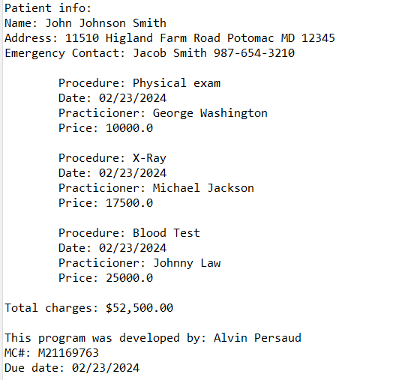

**Case 2**

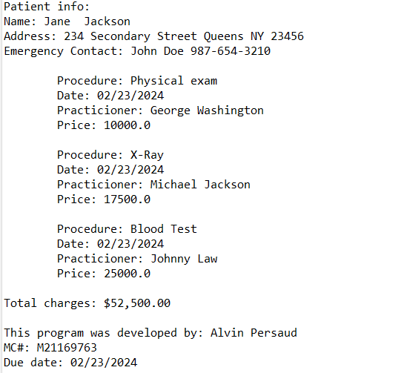

**Case 3**

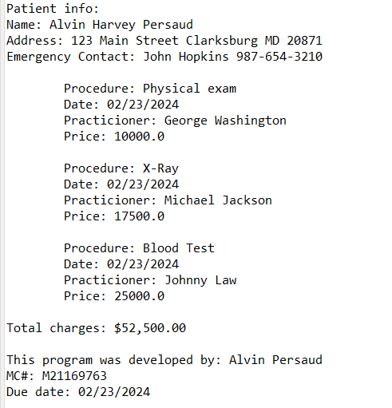

**Case 4**

**Lessons Learned** <Provide answers to the questions listed above>**:**

Write about your Learning Experience, highlighting your lessons learned and learning experience from working on this project.

What have you learned?

I learned how to effectively use multiple classes in one java project

What did you struggle with?

The Patient class has a lot of variables, so initializing all of them in the constructors and creating getter and setter methods for each variable took a while

What would you do differently on your next project?

Nothing, I think I did everything fine

What parts of this assignment were you successful with, and what parts (if any) were you not successful with?

I was successful with creating all the methods for each class. There were no parts I didn’t feel like I did successfully in

Provide any additional resources/links/videos you used to while working on this assignment/project.

**Check List:** <Provide answers to the column Y/N or N/A >**:**

|  |  |  |  |
| --- | --- | --- | --- |
| **#** |  | **Y/N** | **Comments** |
|  | **Assignment files:** |  |  |
|  | * FirstInitialLastName_ Assignment#_Moss.zip |  |  |
|  | * FirstInitialLastName_Assignment#.docx/.pdf |  |  |
|  | * Source java files |  |  |
|  | **Program compiles** |  |  |
|  | **Program runs with desired outputs related to a Test Plan** |  |  |
|  | **Documentation file:** |  |  |
|  | * Comprehensive Test Plan |  |  |
|  | * Screenshots related to the Test Plan |  |  |
|  | * Screenshots of your GitHub account with submitted Assignment# (if required) |  |  |
|  | * UML Diagram (if required) |  |  |
|  | * Flowchart (if required) |  |  |
|  | * Lessons Learned |  |  |
|  | * Checklist is completed and included in the Documentation |  |  |